Project Planning Phase
Project Timeline
Task | Duration
Data Collection & EDA | 4 Days
Data Preprocessing | 4 Days
Feature Selection & Encoding | 3 Days
Model Training & Comparison | 4 Days
Model Evaluation | 3 Days
Flask App Development | 5 Days
Testing & Documentation | 3 Days

Risk & Mitigation
Imbalanced Data: Mitigated by analysing class distribution and applying suitable data balancing techniques when required.
Overfitting of Model: Mitigated by train-test splitting, comparing multiple machine learning models, and evaluating model performance.
Incorrect User Input: Mitigated by using dropdown fields, numeric input fields, and proper input validation in the Flask web application.
Feature Encoding Mismatch: Mitigated by using the same categorical encoding values during model training and Flask prediction.
Model Integration Error: Mitigated by saving the trained model as model.pkl and maintaining the exact feature order during prediction.
Application Failure: Mitigated through local testing of the Flask application and exception handling.
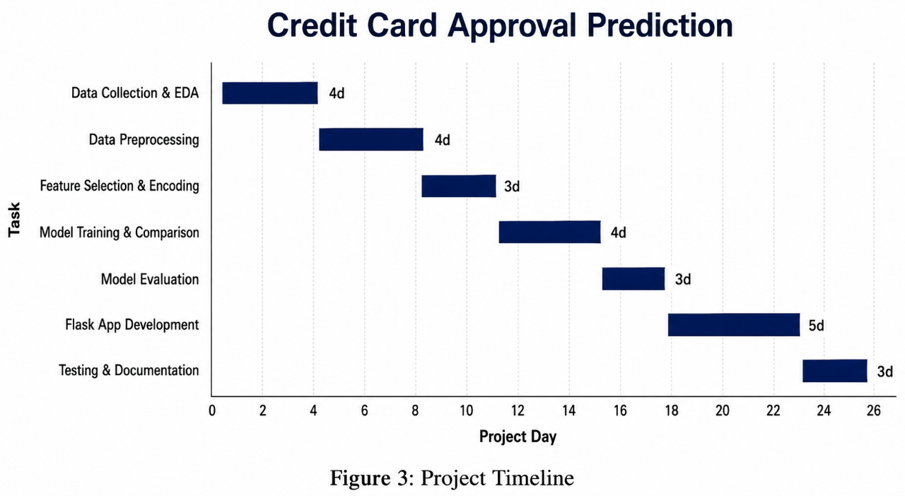

A Sprint is a fixed period or duration in which a team works to complete a set of tasks.
An Epic is a big task or project that is too large to complete in one sprint. It is broken down into smaller tasks (stories) that can be completed over multiple sprints.
A Story is a small task. It is part of an Epic.
A Story Point is a number that represents how much effort a story takes to complete (usually in the form of a Fibonacci series).
- Very Easy task
- Normal task
- Moderate task
- Difficult task
Story Point → (1, 2, 3, 5)

Sprint 1
Data Collection (Epic 1)
- Gathering Historical Credit Card Application Data (USN1) — 2
- Loading Data into the Environment (USN2) — 1
Data Preparation (Epic 2)
- Handling Missing Values (USN3) — 3
- Encoding Categorical Features (Gender, Income Type, Education, etc.) (USN4) — 3
- Feature Selection (Selecting 12 Key Features) (USN5) — 2
Total Story Points in Sprint 1 = 2+1+3+3+2 = 11

Sprint 2
Model Development (Epic 3)
- Splitting Data into Train/Test Sets (USN6) — 1
- Training Random Forest Classifier (USN7) — 5
- Evaluating Model Accuracy & Confidence Score (USN8) — 3
- Saving Trained Model (Pickle File) (USN9) — 2
Total Story Points in Sprint 2 = 1+5+3+2 = 11

Sprint 3
Flask Backend Development (Epic 4)
- Setting up Flask Application Structure (USN10) — 2
- Creating Prediction Route/API (USN11) — 3
- Integrating ML Model with Flask Backend (USN12) — 3
Frontend UI Development (Epic 5)
- Designing Home Page / Applicant Details Form (USN13) — 3
- Creating Dropdown Menus for Categorical Fields (USN14) — 2
- Designing Prediction Result Page (Confidence, Summary, Timestamp) (USN15) — 3
Total Story Points in Sprint 3 = 2+3+3+3+2+3 = 16

Sprint 4
Input Validation (Epic 6)
- Implementing Validation Rules (Income, Age, Employment, Family Members) (USN16) — 3
Testing (Epic 7)
- Writing Test Cases (Valid & Invalid) (USN17) — 2
- Executing Test Cases (USN18) — 2
Deployment (Epic 8)
- Deploying the Web Application (USN19) — 3
Total Story Points in Sprint 4 = 3+2+2+3 = 10

Total Story Points
- Sprint 1 = 11
- Sprint 2 = 11
- Sprint 3 = 16
- Sprint 4 = 10
Velocity = Total Story Points Completed / Number of Sprints
Total Story Points = 11+11+16+10 = 48 Number of Sprints = 4 Velocity = 48/4 = 12
Your team's velocity is 12 Story Points per Sprint.

